BOE Receivables

- Create a billing document using the transaction code FB70

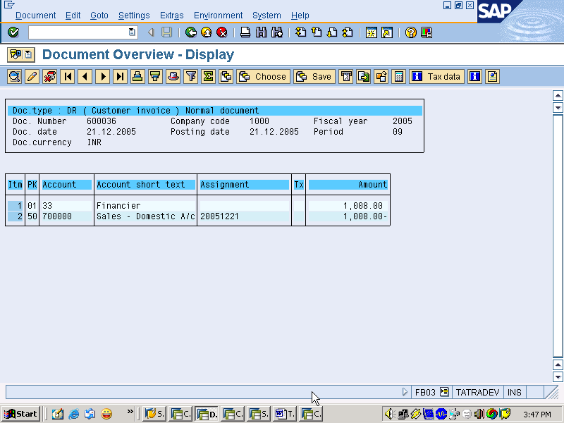

- Using Transaction Code F-36 – Account Bill of Exchange receipts

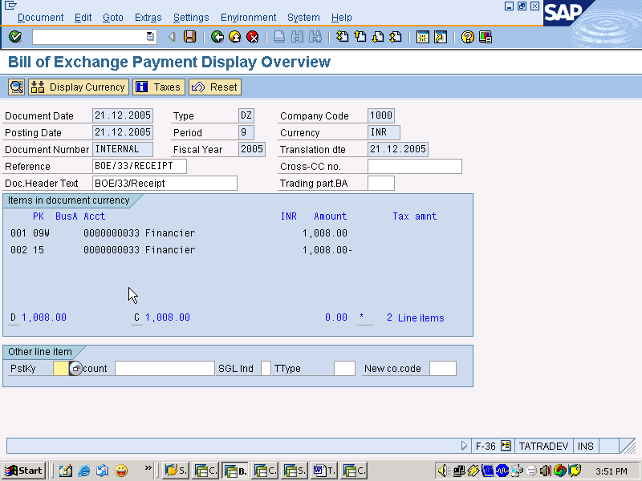
Note: Financier account with Spl GL W represents BOE Receivable.
- View the BOE receivable GL Account ( Only for information purposes):

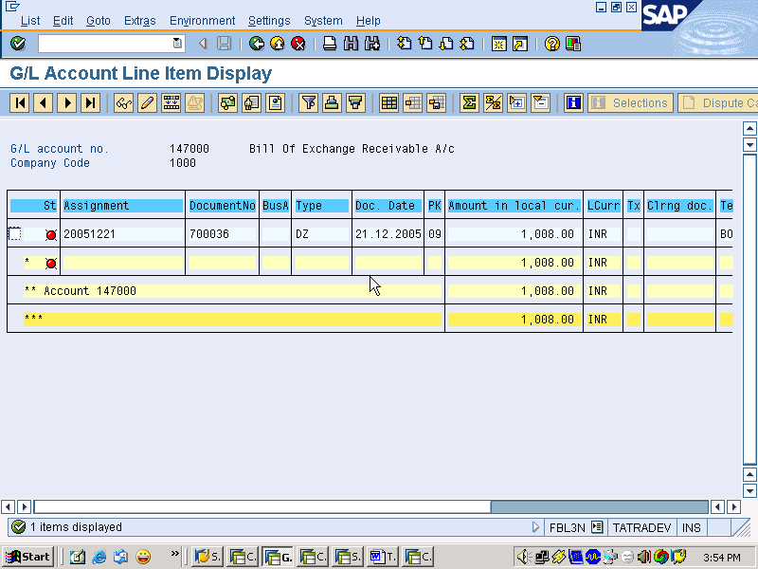

- Use transaction code F-33 to Discount the BOE receivable with bank.

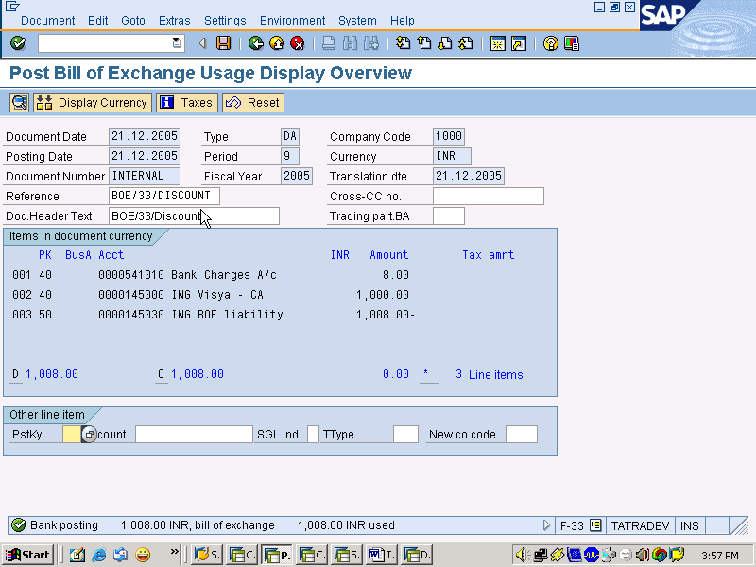
System has created a BOE Liability account for the Bill amount as TTIL is liable to pay the amount if the financier fails to pay the bill on the due date.
- Reverse Contingent liability on the maturity date using the transaction code F-20:

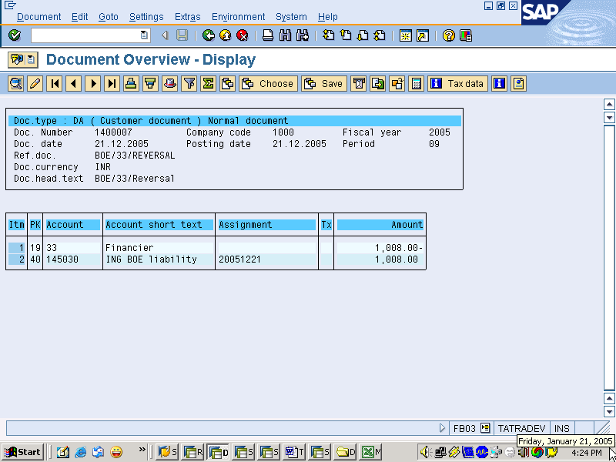

On maturity date BOE liability is cancelled against the BOE receivable.

- View the BOE receivable A/c (only for informational purposes)

